Food Ordering & Delivery Application (Food-Hub) Architecture

Client

API Gateway

<8900>

Customer-Subscriber-Service

Food-Service

Order-Service

Billing-Service

Delivery-Service

MySQL DB

MySQL DB

MySQL DB

MySQL DB

MySQL DB

Spring JPA

Spring JPA

Spring JPA

Spring JPA

Service Registry

Config Server

GitHub Repo

Spring JPA

Feign Client

Feign Client

Feign Client

Feign Client

* So once the application is ready, we will create docker images of each microservice component and run them as docker container.
* Then we will push the services into the Docker Hub Registry, using below docker architecture.

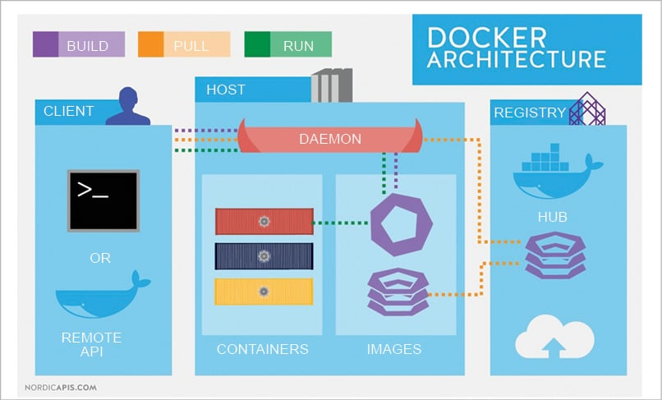

Then To Scale our application we will deploy our application into Kubernetes cluster to quickly scale our application without any downtime.

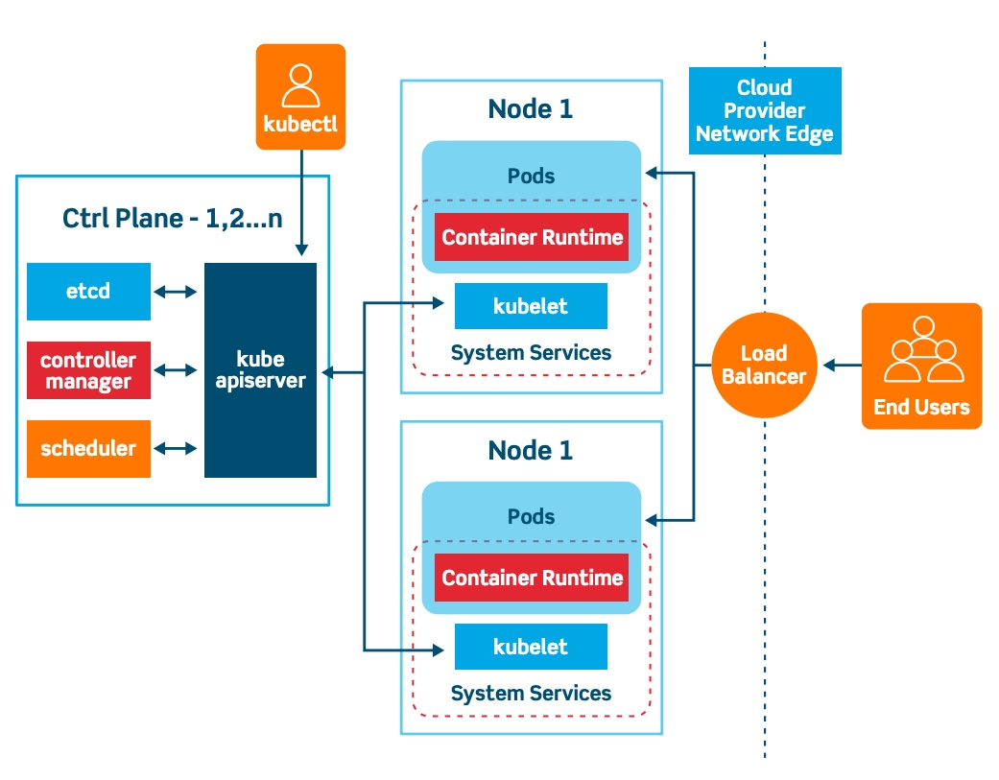

ECS.